A PROJECT REPORT
ON
Movie Recommendation System using Movielens Dataset

Bachelor of Technology
Computer Engineering

GRAPHIC ERA DEEMED TO BE UNIVERSITY
DEHRADUN
By

P.Vikitha
3rd Semester
2017658

ACKNOWLEDGEMENT

Here by I am submitting the project report on “Movie Recommendation System using Movielens Dataset” as per the scheme of Graphic Era Deemed University, Dehradun.
I consider it mine cardinal duty to express the deepest sense of gratitude to Mr. Narayan Chaturvedi Asst. Professor, Department of Computer Science and Application for the invaluable guidance extended at every stage and in every possible way.
Finally I am very much thankful to all the faculty members of the Department of Computer Science and Technology, friends and my parents for their constant encouragement, support and help throughout the period of project conduction.

Project overview
In this project a Collaborative Movie Recommender systems are built on MovieLens dataset with 100,000 movie ratings. These Recommender systems were built using Pandas operations and by fitting deep learning models to suggest movies for the users based on similar users.

Motivation
In today’s digital world where there is an endless variety of content to be consumed like books, videos, articles, movies, etc., finding the content of one’s liking has become an irksome task. On the other hand digital content providers want to engage as many users on their service as possible for the maximum time. This is where recommender system comes into picture where the content providers recommend users the content according to the users’ liking, so I decided to choose this project in attempt to solve the problem of finding the right and meaning content to a wide range of world wide users.

What is recommendation system?
Basically a recommendation system is a system to suggest a user with items which are more relevant to him or her. It is simply like an information filtering system that seeks to predict the "rating" or "preference" a user would give to an item.
Recommender systems are utilized in a variety of areas including movies, music, news, social tags, and products in general. Recommender systems typically produce a list of recommendations.




Most internet products we use today are using recommender systems. YouTube, Netflix, Amazon, Pinterest, and long list of other internet products all are using recommendation systems to filter millions of contents and make personalized recommendations to their users.
Some of the most popular ways are –
- collaborative filtering
- content-based filtering
- knowledge based recommendation system
- hybrid recommender system
Recommender System is a vast concept rooted from a base idea of giving out suggestions to the users. There are wide range of algorithms are used to build a recommender system and the type of recommender system used is mostly dictated by the type of data available. Some of the most common recommendation system are collaborative filtering and content based filtering which we are going to discuss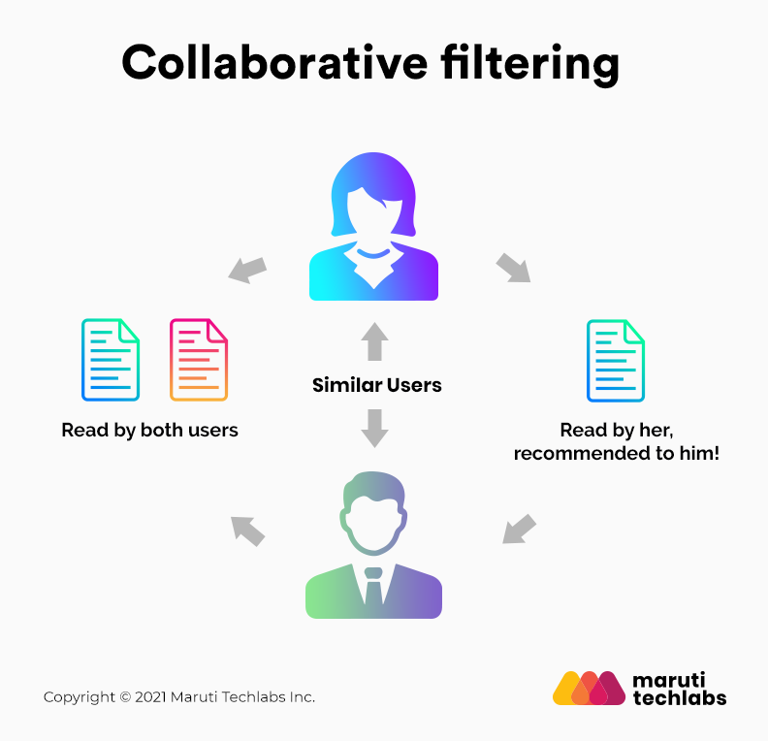

Collaborative recommender system
Collaborative filtering is based on the assumption that people who agreed in the past will agree in the future, and that they will like similar kinds of items as they liked in the past. The system generates recommendations using only information about rating profiles for different users or items. By locating peer users/items with a rating history similar to the current user or item, they generate recommendations using this neighborhood. This approach builds a model from a user’s past behaviors (items previously purchased or selected and/or numerical ratings given to those items) as well as similar decisions made by other users. This model is then used to predict items (or ratings for items) that the user may have an interest in. Collaborative filtering methods are classified as memory-based and model-based.

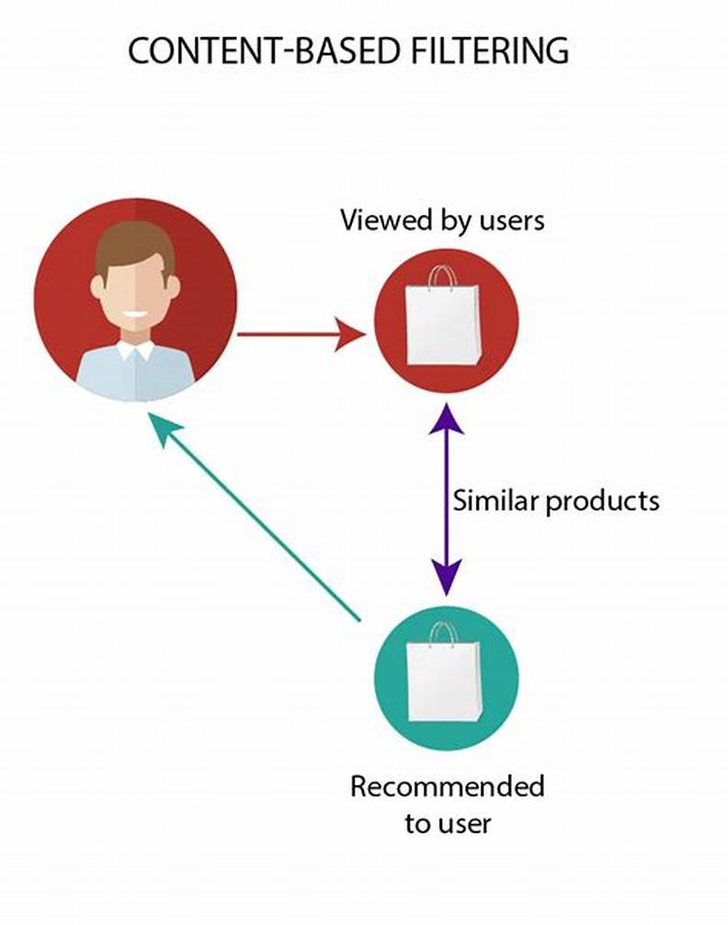

Content based recommender system
This approach utilizes a series of discrete characteristics of an item in order to recommend additional items with similar properties. Content-based filtering methods are based on a description of the item and a profile of the user's preferences. To keep it simple, it will suggest you similar movies based on the movie we give (movie name would be the input) or based on all of the movies watched by a user (user is the input). It extracts features of an item and it can also look at the user's history to make the suggestions.

About Dataset used
MovieLens 100K dataset has been used for this project. MovieLens is a rating dataset from the MovieLens website, which has been collected over some period. Stable benchmark dataset. 100,000 ratings from 1000 users on 1700 movies. Released on 4/1998.
A little about the dataset:
MovieLens data sets were collected by the GroupLens Research Project at the University of Minnesota.
This data set consists of:
- 100,000 ratings (1-5) from 943 users on 1682 movies.
- Each user has rated at least 20 movies.
- Simple demographic info for the users (age, gender, occupation, zip)
About few components loaded from the package which are used in this project:
- data -- The full u data set, 100000 ratings by 943 users on 1682 items. Each user has rated at least 20 movies. Users and items are numbered consecutively from 1. The data is randomly ordered. This is a tab separated list of user id | item id | rating | timestamp.
- info -- The number of users, items, and ratings in the u data set.
- item -- Information about the items (movies); this is a tab separated list of movie id | movie title | release date | video release date | IMDb URL | unknown | Action | Adventure | Animation | Children's | Comedy | Crime | Documentary | Drama | Fantasy | Film-Noir | Horror | Musical | Mystery | Romance | Sci-Fi | Thriller | War | Western |
- Genre -- A list of the genres.

About My Project
Recommendations are made based on the available items and their corresponding ratings data, considering we have no user data available.
Data has been loaded into dataframes using pandas. It had been analyzed and visualized to draw some key insights before going further into recommendations.
Quantifying the similarity
Here we have used the angular distance between two points. By applying some trigonometry we can find the angular distance.
One of them are cosine similarity,
The cosine similarity computes the similarity between two samples. The two samples can be obtained from the same distribution or different distributions. The two samples should have the same number of features.
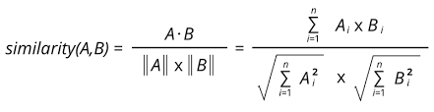
The cosine similarity ranges from −1 to 1. 1 means the two samples are the most similar and −1 means the two samples are the least similar.
Another one is Pearson correlation,
The Pearson correlation coefficient computes the correlation between two jointly distributed random variables.
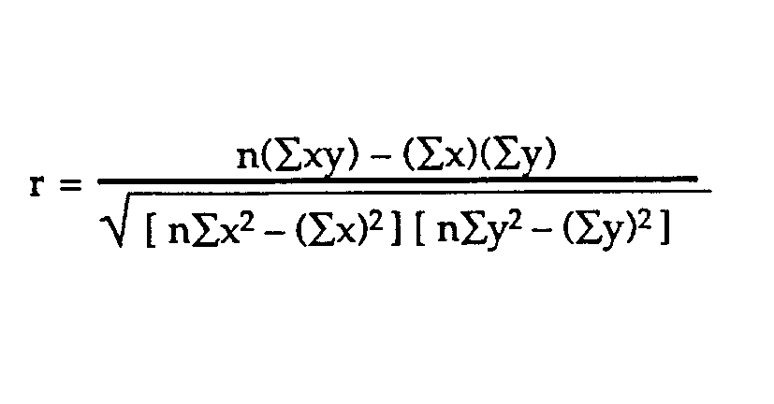
The cosine similarity ranges from −1 to 1. 1 means the two random variables are perfectly positively correlated, −1 means the two random variables are perfectly negatively correlated.
I’ve used Pearson correlation in my code
corrMatrix = userRatings.corr(method='person')
corrMatrix.head(100)

Common Challenges
In this project, following challenges were encountered while building the recommender system:
- cold start
- data sparsity
- popular bias (how to recommend products from the tail of product distribution)
- User Inconvinience with spelling while giving movie names as input (can't expect to give exact movie name everytime)
- pool relationship between like-minded yet sparse users

